*Journal of Advances in Modeling Earth Systems*

Supporting Information for

**Interactive atmospheric chemistry for enhanced science capabilities of the Energy Exascale Earth System Model version 3**

Qi Tang1, Michael J. Prather2, Ziming Ke1, Jinbo Xie1,3, Hsiang-He Lee1, Mingxuan Wu4, Philip Cameron-Smith1, Hailong Wang4, Wuyin Lin5, Shaocheng Xie1

1Lawrence Livermore National Laboratory, Livermore, CA, USA

2Departments of Earth System Science and Computer Science, University of California, Irvine, CA, USA

3Princeton University, Princeton, NJ, USA

4Pacific Northwest National Laboratory, Richland, WA, USA

5Brookhaven National Laboratory, Upton, NY, USA

Corresponding author: Qi Tang ([tang30@llnl.gov](mailto:tang30@llnl.gov))

**Contents of this file**

Figures S1 to S6

Tables S1 to S2

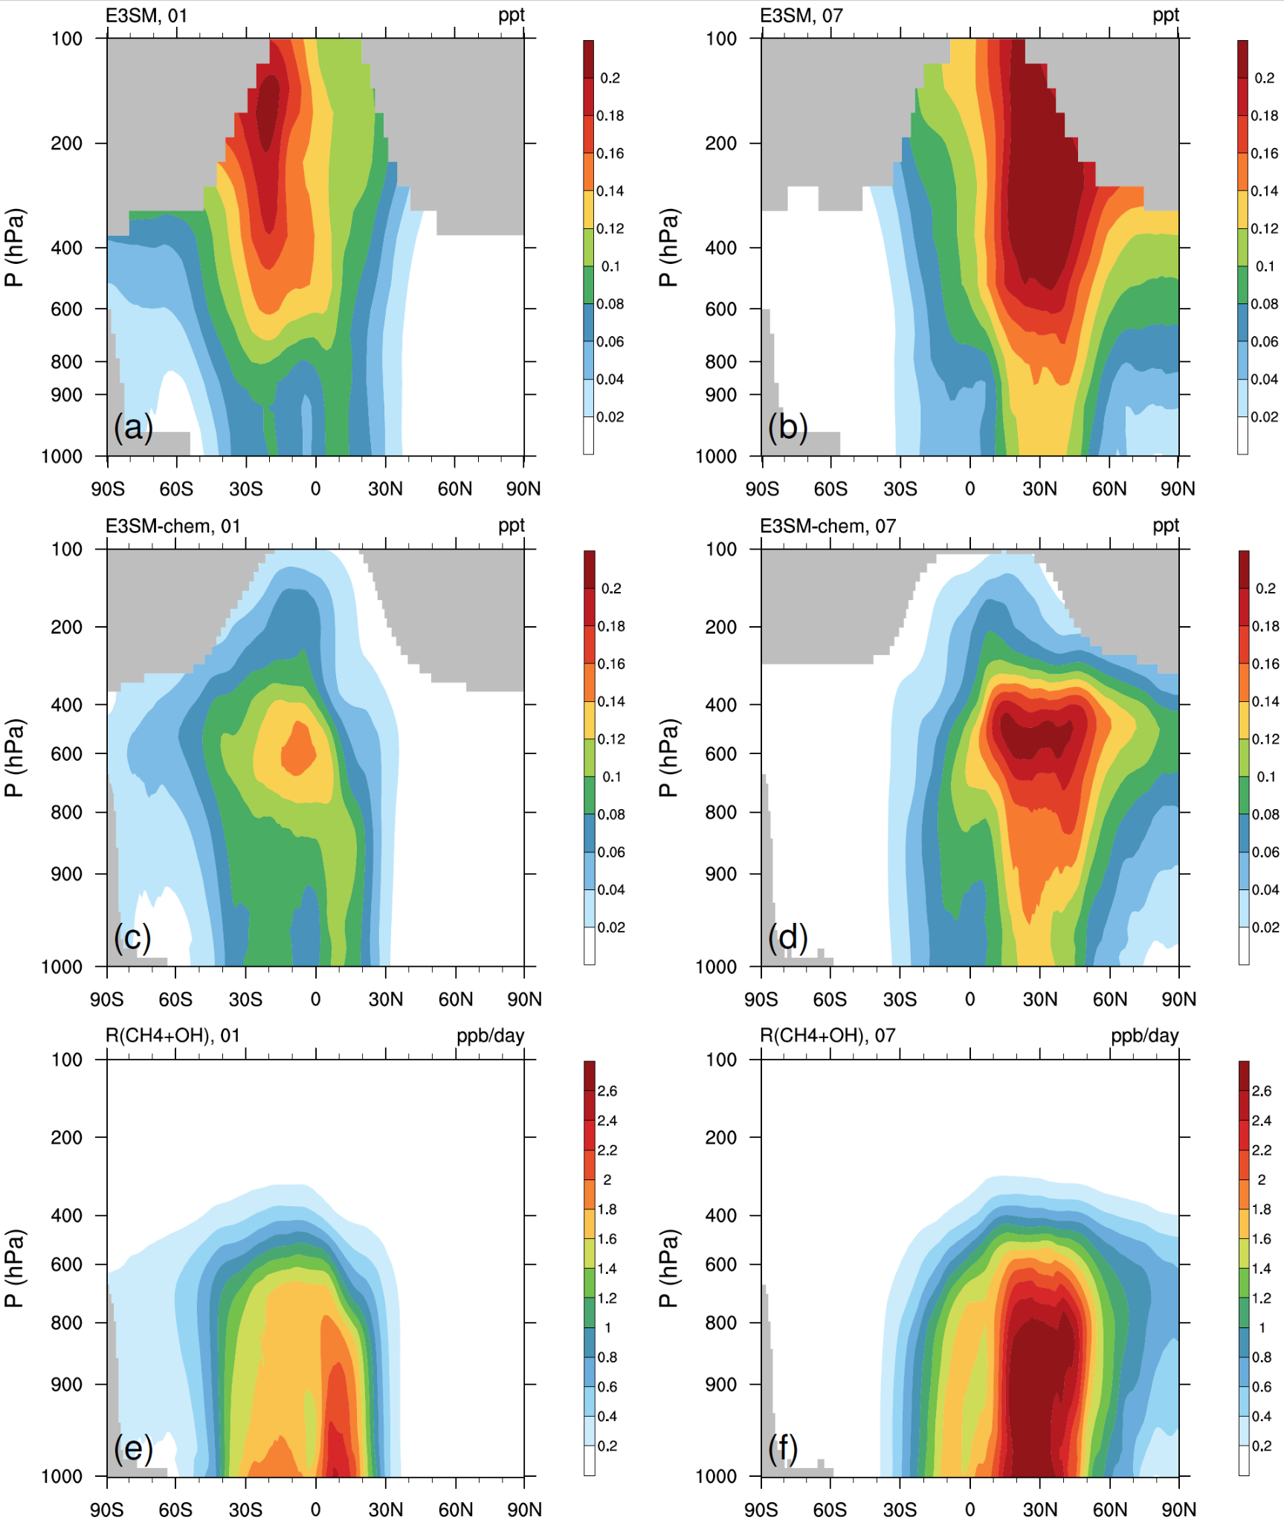

Figure S1. Tropospheric OH concentration (unit: ppt; a-d) and methane loss rate (unit: ppb/day, e-f) from the CH4+OH reaction in January (01) and July (07) 2005.

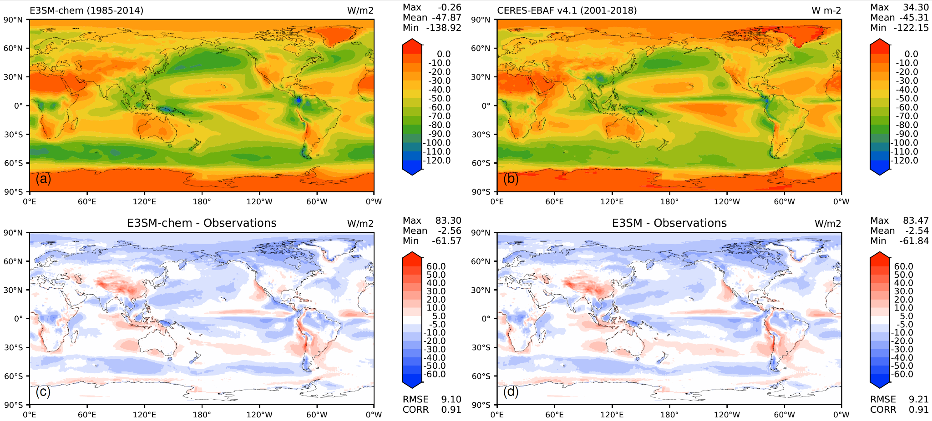

Figure S2. Top-of-the-atmosphere (TOA) shortwave cloud radiative effects (CRE) (unit: W/m2) annual mean climatology (1985-2014) for (a) E3SM-chem, (b) CERES-EBAF v4.1 observation, (c) E3SM-chem - observation, and (d) E3SM - observation.

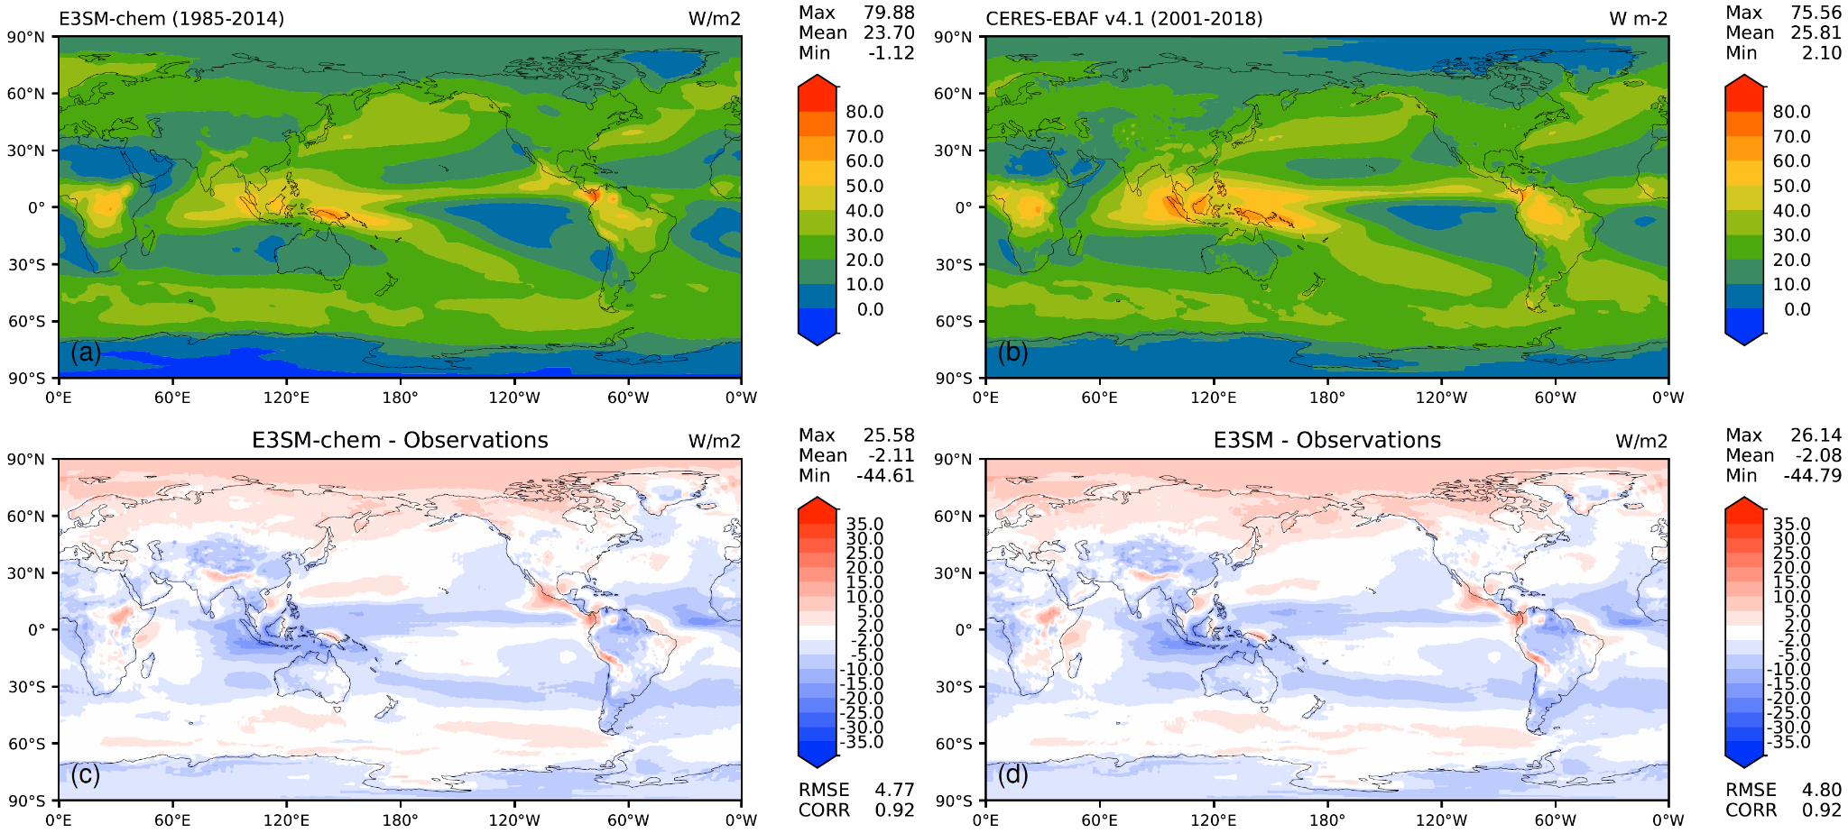

Figure S3. Same as Fig. S2, but for TOA longwave CRE.

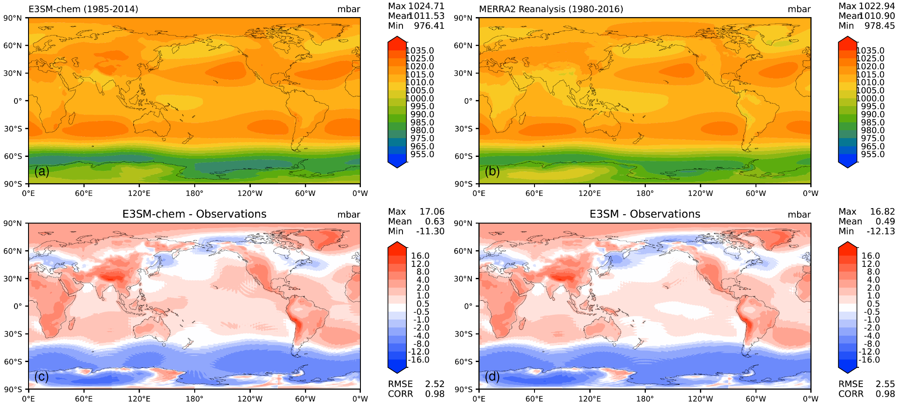

Figure S4. Same as Fig. S2, but for sea-level pressure.

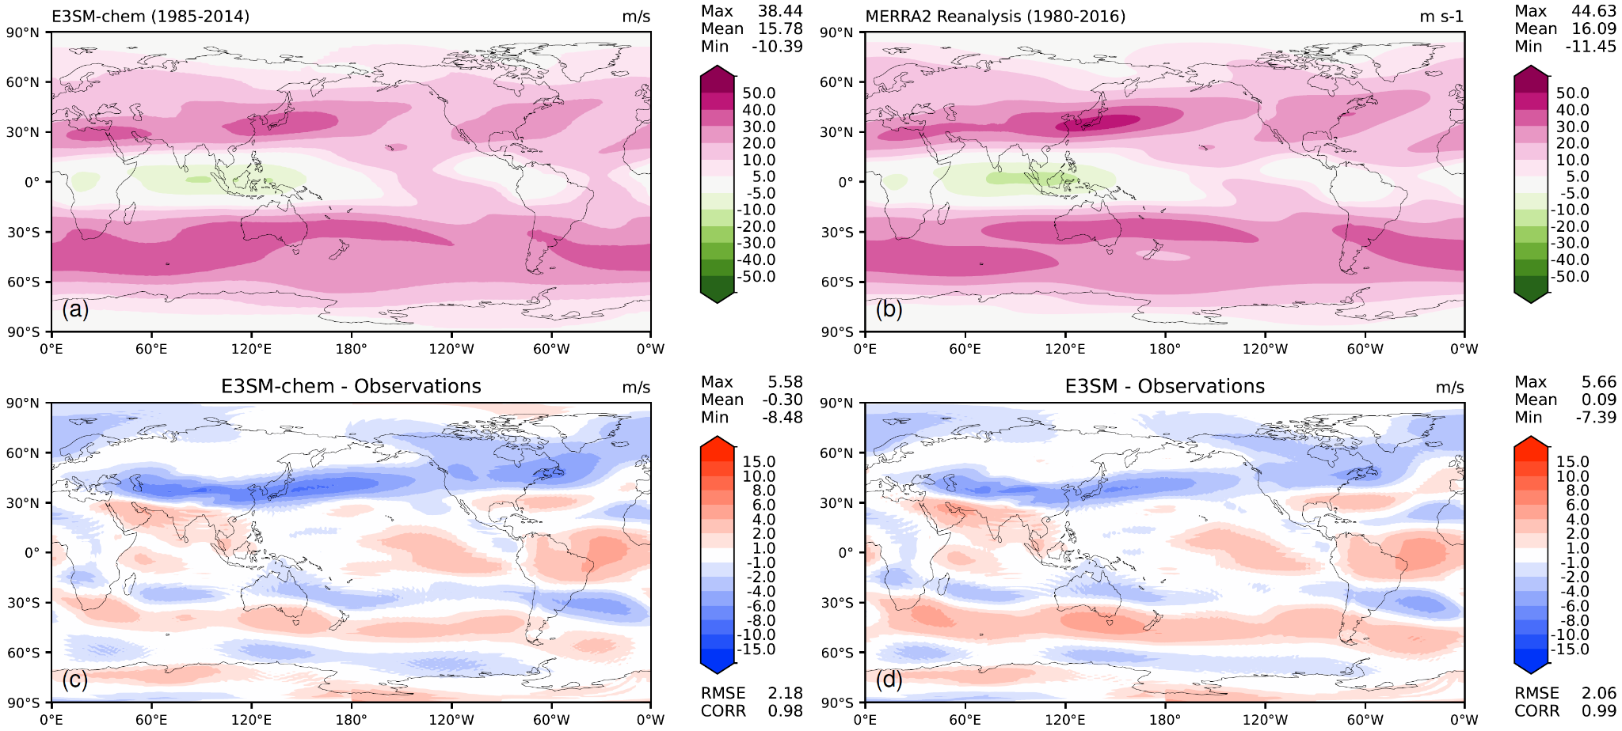

Figure S5. Same as Fig. S2, but for 200-hPa zonal wind.

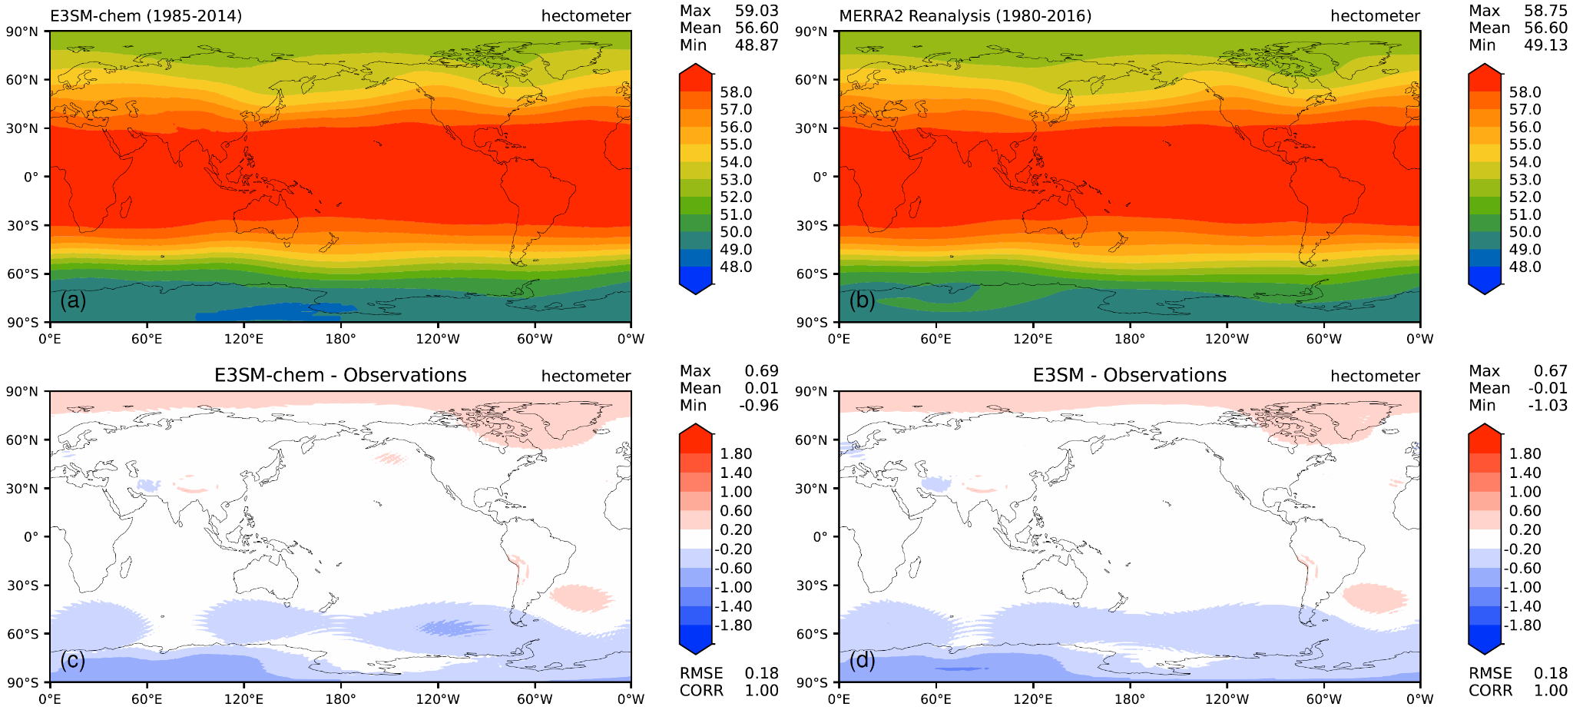

Figure S6. Same as Fig. S2, but for 500-hPa geopotential height.

Table S1. Global annual averages of gas and aerosol emissions (units: Tg/year) from years 2010-2014. SOAG = secondary organic aerosol gas precursor, DMS = dimethyl sulfide, BC = black carbon, POM = particulate organic matter.

|  |  |  |  |  |  |  |  |  |
| --- | --- | --- | --- | --- | --- | --- | --- | --- |
| Species | Anthropogenic | Biomass Burning | Lightning & Volcanicc | Biogenic | Ocean | Soil | Aircraft | Total |
| CO | 615.97 | 320.30 | 0 | 94.12 | 19.91 | 0 | 0 | 1050.31 |
| NO | 91.78 | 13.37 | 16.92 (or 7.9 Tg N/year) | 0 | 0 | 10.62 | 0 | 132.69 |
| NO2 | 0 | 0 | 0 | 0 | 0 | 0 | 3.00 | 3.00 |
| Isoprene | 0 | 0.45 | 0 | 611.13 | 0 | 0 | 0 | 611.58 |
| HCHO | 2.51 | 4.45 | 0 | 4.96 | 0 | 0 | 0 | 11.92 |
| C2H4 | 5.87 | 4.03 | 0 | 30.76 | 1.40 | 0 | 0 | 42.05 |
| C2H6 | 6.68 | 3.19 | 0 | 0.32 | 0.98 | 0 | 0 | 11.18 |
| C3H8 | 6.72 | 0.60 | 0 | 0.03 | 1.29 | 0 | 0 | 8.65 |
| CH3CHO | 1.24 | 3.35 | 0 | 19.81 | 0 | 0 | 0 | 24.40 |
| CH3COCH3 | 0.46 | 1.33 | 0 | 38.42 | 0 | 0 | 0 | 40.21 |
| SOAG | 21.38a | 28.49b | 0 | 42.22 | 0 | 0 | 0 | 92.08 |
| DMS | 0 | 0 | 0 | 0 | 37.59 | 0 | 0 | 37.59 |
| SO2 | 110.47 | 2.11 | 24.60 | 0 | 0 | 0 | 0 | 137.18 |
| sulfate | 5.09 | 0.097 | 1.13 | 0 | 0 | 0 | 0 | 6.32 |
| BC | 7.93 | 1.71 | 0 | 0 | 0 | 0 | 0 | 9.64 |
| POM | 27.08 | 21.29 | 0 | 0 | 0 | 0 | 0 | 48.38 |
| Dust | 0 | 0 | 0 | 0 | 0 | 3884.85 | 0 | 3884.85 |
| Sea Salt | 0 | 0 | 0 | 0 | 2314.91 | 0 | 0 | 2314.91 |

aFossil Fuel only

bIncluding both biomass burning and biofuel

cLightning refers to NO source and Volcanic to SO2 and sulfate. The volcanic emissions are run in the chemistry as constant background degassing emissions because the stratospheric injections from explosive volcanic eruptions do not directly affect tropospheric chemistry; their impact on photolysis rates is not considered.



**Table SX.** Tracer list of interactive chemistry in E3SM-chem.

|  |  |  |  |  |
| --- | --- | --- | --- | --- |
| Linoz v3* | | | | |
| O3 | CH4 | N2O | NOY | e90 |
| chemUCI | | | | |
| O3D | OH | CH4 | HO2 | H2O2D |
| CH2OD | CH3OO | CH3OOHD | NOD | NO2D |
| NO3 | N2O5D | HNO3D | PAND | COD |
| C2H6 | C3H8 | C2H4 | ROHO2 (C2H5O3) | C2H5O2 |
| C2H5OOHD | CH3CHOD | CH3CO3 | ISOP (C5H8) | ISOPO2 |
| CH3COCH3D | MVKO2 (C4H7O4) | MVKMACR (Methyvinylketone & Methacrolein) | | |

*Stratospheric H2O is diagnosed by Linoz v3.

DTracers with dry deposition following Wesely (1989)

**Table SY.** Gas chemistry configuration differences between E3SM and E3SM-chem.

|  |  |  |
| --- | --- | --- |
|  | E3SM | E3SM-chem |
| Stratosphere | Linoz v2 | Linoz v3 |
| Troposphere | No interactive chemistry, prescribed GHGs and oxidants | Interactive O3-CH4-HOx-NOx-NMVOCs chemistry |
| Lightning NOx | No | Yes, parameterized from clouds |

**References:**

Wesely, M. L. (1989). Parameterization of surface resistances to gaseous dry deposition in regional-scale numerical models. *Atmospheric Environment (1967)*, *23*(6), 1293–1304. https://doi.org/10.1016/0004-6981(89)90153-4