**Backyard Worlds: Planet 9 Follow-Up Campaign**

**Data already in the archive:**

* Magellan/FIRE Prism

Spectra of 17 targets

* Magellan/FIRE Echelle

Spectrum of 1 target

* OMM (Mont-Mégantique)/CPAPIR -- partially complete (18/05/08, 18/05/09, 18/06/21, 18/09/07, 18/09/09, 18/09/22, 18/09/29, 18/11/18, 19/03/19, 19/03/20, 19/03/25, 19/03/26, 19/04/01, 19/04/10, 19/04/11, 19/04/13, 19/04/17, 19/04/28, 19/04/29, 19/04/30, 19/05/04), more data expected
* Apache Point Observatory (APO)/Triplespec

spectra of 2 targets

* IRTF SpeX (June 15)

Spectra of 9 targets

* FourStar, data for BYW1930-2059
* APO spectra, September 28, 2018

Spectra of 4 targets

* Spitzer -- partially complete, more data expected (12 targets)
* Keck NIRES -- partially complete (October 2018)
* APO Triplespec, Dec 19, 2018 (2 spectra, reduced)

**Data not yet uploaded (observing run completed)**

* Gemini-North/NIRI Fast Turnaround

Images of 16 targets

* Blanco 4m/ARCoIRIS

Spectra of 17 BDs

* Keck NIRES, T dwarf spectroscopy (Adam Burgasser), August 31 (2nd half)/October 26 (2nd half)/November 16 (2nd half)/February 9, 13 and 19 (2nd half, respectively)
* IRTF SpeX (Jackie Faherty), 40 BD candidates, August 28, September 30, November 24, 2018
* Magellan (Jackie Faherty), December 1
* APO TripleSpec (Katelyn Allers), January 18, 2019

**Upcoming Observing Dates:**

* Gemini NIRI queue mode 8 Y dwarf candidates
* Magellan, July 2019
* APO TripleSpec (Katelyn Allers), March 22, 2019.
* IRTF SpeX (Jackie Faherty), 40 BD candidates, January 22 and 23, 2019
* Hubble/WFC3 (Jackie Faherty), Y (F105W) and J (F125W) band photometric confirmation of Y dwarfs, 5 orbits, 5 targets
* Spitzer (Jackie Faherty), 26.8 hrs, 65 targets -- partially complete (12 targets), see above
* OMM (Mont-Mégantique) (Jonathan Gagné) -- 60 targets, partially complete (2 nights), see above

**List of successful telescope proposals (Telescope, Instrument, PI, Allocated Time, PID):**

* See above for successful telescope proposals with observing dates already scheduled

**Proposals in Progress:**

* Gemini-South/Flamingos 2, 13.7 hours, 27 targets; proposal submitted, pending
* Gemini-North/GNIRS, 9.4 hours, 5 targets; proposal submitted, pending
* APO (Katelyn Allers), 2 half-nights in Q1 (2019)

**Other ideas:**

* A “Placeholder” JWST proposal saying take spectra of the two coldest Y dwarfs we find
* Another Gemini NIRI fast-turnaround proposal? Next deadline Feb 28. We’ll probably wait till March.
* Magellan Proposals (Adam)
* Feeding targets directly to the Magellan engineers. (Jackie)
* Mont-Megantique University of Montreal telescope for J band photometry. Due roughly April 6
* NIHTS DCT (with Joe Llama)
* More APO with Katelyn and John

**Notes on Follow-Up Data**

Here be our notes on the spectra we’ve already taken of brown dwarfs and other objects.

**OMM April 13, 17, 28-30, May 4, 2019**

**Observer: Jonathan Gagné**

**== April 10 2019 ==**

**BYW1257+7153:** Not detected.

5-sigma mag limit = 18.93.

Sylvie: Mark as done and remove target.

**BYW1401+4325:** Something barely detected at the expected position.

5-sigma mag limit = 17.8

Sylvie: Mark as done and remove target (data from April 11 is great)

**BYW1416+2322:** Something clearly detected near expected position.

5-sigma mag limit = 19.0

Sylvie: Mark as done and remove target.

**BYW1424+2304:** No proper motion so I can’t say but data is great.

5-sigma mag limit = 18.9

Sylvie: Mark as done and remove target.

**BYW1757+1832:** No proper motion so I can’t say but data is great.

5-sigma mag limit = 18.4

Sylvie: Mark as done and remove target.

**BYW1811+6658:** No proper motion so I can’t say but data is great.

5-sigma mag limit = 18.6

Sylvie: Mark as done and remove target.

**BYW1851+6713:** No detection. Data is not bad but could be better.

5-sigma mag limit = 17.5

Sylvie: We could redo this one with more exposure time or better weather.

**== April 11 2019 ==**

**BYW1042-0039:** No detection. Data is not great.

5-sigma mag limit = 17.3

Sylvie: Redo with more exposure time or better weather. Ideally we want 5 sigma mag limit > 19

**BYW1211+7626:** Great data. Cannot say if detected without PM but there might be something there.

5-sigma mag limit = 19.5

Sylvie: Mark as done and remove target.

**BYW1257+7153:** No detection. Data is great.

5-sigma mag limit = 19.4

Sylvie: Mark as done and remove target.

**BYW1401+4325:** Something well detected at expected position.

5-sigma mag limit = 17.3

Sylvie: Mark as done and remove target. Looks like the 5-sigma limit may have been calculated wrong here. Data is better than that of last night visually.

**BYW1416+2322:** Something barely detected at expected position.

5-sigma mag limit = 16.8

Sylvie: Mark as done and remove target (data from Apr 10 is great).

The other dates are in table format below:

|  |  |  |  |
| --- | --- | --- | --- |
| **NAME** | **OMM_obsdate** | **OMM_MAG5SIG** | **Fchart Comments** |
| **NAME** | **omm_obsdate** | **omm_mag5sig** | **omm_fchart_comments** |
| **A** | **A** | **A** | **A** |
| 0008+5204 | 190430 | 15.0 | Between WISE and predicted position; well detected. Mark as completed. |
| 0754+0900 | 190413 | 18.4 | No detection. Mark as completed. |
| 0758+5711 | 190430 | 18.7 | No PM but something detected near WISE position. Mark as completed. |
| 0806-0820 | 190417 | 12.9 | No detection. Mark as completed. |
| 0830+2837 | 190417 | 19.5 | 190417: No detection. 190320: No detection. Data looks good 5-sigma J limit = 18.449. Mark as completed. |
| 0847+2335 | 190430 | 18.8 | No PM but something detected near WISE position. Mark as completed. |
| 0911+2146 | 190417 | 18.5 | 190429: No detection. Redo with more signal. 190417: Very well detected at expected position. Mark as completed. |
| 0918+1936 | 190429 | 12.8 | Data is bad. Redo 20 min. |
| 0925+3442 | 190413 | 18.6 | Detection at expected position. Mark as completed. |
| 0930+6046 | 190430 | 18.6 | Very good detection exactly at the predicted position. Mark as completed. |
| 0940-2208 | 190413 | 17.7 | Barely detected. Would be worth hitting for 2h |
| 1014-2239 | 190413 | 18.0 | No detection. Redo with 20 min in better weather |
| 1019+2052 | 190430 | 17.8 | Detected between WISE and predicted positions. Could be done again 20 min. |
| 1034+1612 | 190413 | 18.5 | Detection near expected position. Mark as completed. |
| 1040+4503 | 190417 | 19.6 | 190320: Very clear detection exactly at the WISE position. This is probably not good at all; we do not have a PM estimate for this object. 5 sigma J mag limit = 19.351. 190417: Same conclusion. Mark as completed. |
| 1042-0039 | 190417 | 19.2 | 190320: Data looks good no detection. 5 sigma J mag limit = 18.206. 190411: No detection. Data is not great. 5-sigma mag limit = 17.3. 190417: Something barely detected between WISE and expected position. This would be worth hitting for 2h. |
| 1053+2853 | 190417 | 18.8 | No detection at all. Mark as completed. |
| 1102+3503 | 190413 | 18.6 | Maybe 0.5sig detection at expected position. Would be worth hitting for 2h. |
| 1124+1756 | 190430 | 17.3 | No detection. Repeat with 2h. |
| 1124+6630 | 190413 | 18.6 | Barely detected between WISE and expected. Mark as completed. |
| 1130+3139 | 190430 | 18.1 | Possibly a detection near expected position but it seems a bit elongated. Mark as completed. |
| 1131+1650 | 190430 | 17.4 | Detected between WISE and expected positions. Redo 20 min. |
| 1134+5835 | 190417 | 18.5 | No PM. Unclear which object it is. 5 sigma J mag limit = 18.568. Mark as completed. |
| 1138+7212 | 190430 | 19.0 | Very well detected near expected position. Mark as completed. |
| 1141+2839 | 190430 | 16.0 | No detection. Redo with 2h. |
| 1143+4013 | 190413 | 12.6 | Barely detected near expected position. Redo with 20 min in better weather. This is probably not a T9. |
| 1146+3424 | 190430 | 18.3 | Almost a detection near expected position. Redo 2h. |
| 1202+3052 | 190430 | 17.1 | Clear detection at expected position. Mark as completed. |
| 1252+5220 | 190413 | 18.5 | Very good detection near expected position. Mark as completed. |
| 1330-1359 | 190413 | 18.2 | Detection near expected position. Mark as completed. |
| 1341+5741 | 190430 | 18.4 | Almost a detection near expected position. Redo 2h. |
| 1353-0037 | 190417 | 18.4 | No detection. Mark as completed. |
| 1400+2538 | 190413 | 18.5 | No detection. Mark as completed. |
| 1425+2621 | 190430 | 15.1 | No detection. Redo with 20 min. |
| 1433+8401 | 190413 | 18.2 | 190320: I do not have a PM estimate so I can't say if we detected it, but the data is great. 5 sigma J mag limit = 18.502. 190413: Data is good. Mark as completed. |
| 1451+5625 | 190413 | 18.5 | 190320: No detection; we could get better data I'll ask for more. 5 sigma J mag limit = 17.190. 190413: Clear detection. Mark as completed. |
| 1509+7015 | 190504 | 18.6 | Very well detected at expected position. Mark as completed. |
| 1531+5951 | 190413 | 18.2 | No PM but data is great. Mark as completed. |
| 1540-1139 | 190413 | 12.1 | No PM but data is not deep enough. Redo 20 min in better weather. |
| 1606+5708 | 190504 | 18.5 | Very well detected at expected position. Mark as completed. |
| 1608-2442 | 190413 (J5sig=16.16) | 17.1 | 190413: Not deep enough. 190417: Data is bad (wind?). Something barely detected near WISE position but no PM. Would be worth hitting for 2h. |
| 1622+3701 | 190504 | 18.8 | No PM but something barely detected near WISE position. Would be worth redoing and starting for 2h. |
| 1623+8414 | 190504 | 18.3 | Very well detected and moving in the wrong direction ! Mark as completed |
| 1627-2443 | 190428 | 12.0 | No detection but weather was not good. Redo 20 min. |
| 1757+1832 | 190413 | 17.1 | 190410: No proper motion so I can’t say but data is great. 5-sigma mag limit = 18.4. 190413: A little less deep but 190410 is good. Mark as completed |
| 1811+6658 | 190413 | 17.1 | 190410: No proper motion so I can’t say but data is great. 5-sigma mag limit = 18.6. 190413: Less deep but 190410 is good. Mark as completed. |
| 1851+6713 | 190417 | 19.3 | 190410: No detection. Data is not bad but could be better. 5-sigma mag limit = 17.5. 180509: Not detected but weather wasnt good. 190417: No detection at all. Mark as completed. |
| 2059+6627 | 190413 | 16.6 | Data is not great. Redo 20 min in better weather. |



**OMM March 19-20, 25-26, April 1, 10-11, 2019**

**Observer: Jonathan Gagné**

**Date 190319:**

**BYW1434-0839:** Data looks good, no detection. Target is either very late or non existent. 5-sigma limit is J = 18.536

**BYW1435-1544:** Data looks good, no detection. Target is either very late or non existent. 5-sigma limit is J = 18.407

**BYW1627-2443:** Weather was not good, no detection. 5-sigma limit is J = 15.903

**Date 190320:**

**BYW0627-0709:** Possibly barely detected at less than 1 sigma. 5-sigma limit is J=17.501. This may not be a real object given the spt estimate of T2. I'll remove it from the OMM target list, let me know if we should get a deeper image.

**BYW0653+1312**: Very clear detection but proper motion may be a bit off. 5-sigma J limit=17.6945

**BYW0835+6213:** We do not have a proper motion so I cannot confidently say if it is detected but the data looks good. 5 sigma J limit=18.929

**BYW1905+7002:** Slight detection at AllWISE position which seems a bit elongated. We do not have a PM estimate for this object. It is at risk of being a bacgrkound Galaxy. 5 sigma J limit=18.963

**BYW1040+4503:** Very clear detection exactly at the WISE position. This is probably not good at all; we do not have a PM estimate for this object. 5 sigma J mag limit = 19.351

**BYW1042-0039:** Data looks good, no detection. 5 sigma J mag limit = 18.206

**BYW1139+5835:** I do not have a PM estimate so I can't say if we detected it, but the data is great. 5 sigma J mag limit = 18.568

**BYW1211+7626:** I do not have a PM estimate so I can't say if we detected it, but the data is great. 5 sigma J mag limit = 18.629

**BYW1241+2205:** Data is bad; no conclusions. 5 sigma J mag limit = 15.304

**BYW1433+8401:** I do not have a PM estimate so I can't say if we detected it, but the data is great. 5 sigma J mag limit = 18.502

**BYW1436+6216:** Very clear detection near the predicted position. 5 sigma J mag limit = 18.444

**BYW1451+5625:** No detection; we could get better data I'll ask for more. 5 sigma J mag limit = 17.190

All objects below have no calculation of 5-sigma J band limit. This is because the OMM people changed data reduction codes and I just asked them to re-implement this calculation.

**Date 190325:**

**BYW1220+5407:** No detection.

**BYW1249+2316:** Clear detection at expected position.

**BYW1516+7217:** Very faint object not far from predicted position.

**BYW1639+1840:** No detection but data looks great.

**BYW1827+5645:** Possible very faint object at expected position. Data looks great

**BYW1835+6005:** I do not have a PM estimate so I can't say if we detected it, but the data looks good.

**Date 190326:**

**BYW0927+5834:** Possibly an extremely faint object at the WISE position. Data quality looks ok.

**BYW1055+5443:** Possibly an extremely faint object near the expected position. Data looks good.

**BYW1059+2857:** No detection but I have no PM. Data looks ok.

**BYW1159+6717:** No detection. Data looks ok.

**BYW1241+2205:** No detection. Data looks ok.

**BYW1257+5552:** I have no PM but there is a bright object right next to the WISE position this may be our object. Data looks good.

**BYW1304+2819:** Very clear detection at expected position.

**BYW1313+2259:** Very clear detection at about half the expected PM.

**Date 190401:**

**BYW0326+4210:** Great data. Few sigma detection not far from expected position.

**BYW0355+4743:** Clear detection a bit further than expected position but field is a bit crowded. Great data.

**BYW0615+1526:** Extremely faint detection near expected position. Data is great.

**BYW0623+0715:** Clear detection not far from expected position. Great data.

**BYW0645+5240:** I do not have a PM estimate so I can't say if we detected it, but the data looks good.

**BYW0649+5938:** Very clear detection near expected position.

**BYW0653+1312:** Very clear detection near expected position.

**BYW0704+6002:** I do not have a PM estimate so I can't say if we detected it; but there is a faint object near the WISE position and the data looks good.

**BYW0709+4914:** Maybe a very slight detection data looks great.

**BYW0738+5440:** Very clear detection slightly off from expected position.

**== April 10 2019 ==**

**BYW1257+7153:** Not detected.

5-sigma mag limit = 18.93.

**BYW1401+4325:** Something barely detected at the expected position.

5-sigma mag limit = 17.8

**BYW1416+2322:** Something clearly detected near expected position.

5-sigma mag limit = 19.0

**BYW1424+2304:** No proper motion so I can’t say but data is great.

5-sigma mag limit = 18.9

**BYW1757+1832:** No proper motion so I can’t say but data is great.

5-sigma mag limit = 18.4

**BYW1811+6658:** No proper motion so I can’t say but data is great.

5-sigma mag limit = 18.6

**BYW1851+6713:** No detection. Data is not bad but could be better.

5-sigma mag limit = 17.5

**== April 11 2019 ==**

**BYW1042-0039:** No detection. Data is not great.

5-sigma mag limit = 17.3

**BYW1211+7626:** Great data. Cannot say if detected without PM but there might be something there.

5-sigma mag limit = 19.5

**BYW1257+7153:** No detection. Data is great.

5-sigma mag limit = 19.4

**BYW1401+4325:** Something well detected at expected position.

5-sigma mag limit = 17.3

**BYW1416+2322:** Something barely detected at expected position.

5-sigma mag limit = 16.8

**APO Spectra, 9/28/18**

**Observer: Katelyn Allers**

Spectra that are *_xtc.fits are the telluric-corrected spectra with no merging. Spectra that are *_apo.fits are telluric-corrected, merged, cleaned and smoothed with a gaussian of 2.1 pixels (the slit width). 3 look like L dwarfs and 1 looks like a mid-T dwarf. The T dwarf has two different reductions: 1 done by reducing individual AB pairs (BYW_2221+3417_xtc.fits) for which getting a trace was tricky, and one done by first combining all of the “A” frames together and all of the “B” frames together and then subtracting/extracting (faintBYW_2221+3417_xtc.fits). I did not stitch together the orders for the T dwarf, as there wasn’t much overlap between orders that actually had flux.

Comments by Adam Schneider:

I just did some quick comparisons to spectral standards and get:

1727-0111 = L5

1829+2600 = L1

1949+1713 = L3

2221+3417 = T5 (maybe T6)

@Marc — I would say a distance estimate for 1829+2600 of 25.7 pc compared to Gaia’s 29.65 is actually pretty good.

1727-0111 is a little odd though. I had a pretty good reason for a later spectral type estimate than the actual type (there’s a really red source nearby likely contaminating the WISE photometry), which would lead to distance discrepancies with Gaia. However, it looks like an L5 to me, so…idk. Hmmmmmmm…..

—Adam

PS — I did a bit of smoothing for these comparisons, especially for 2221+3417

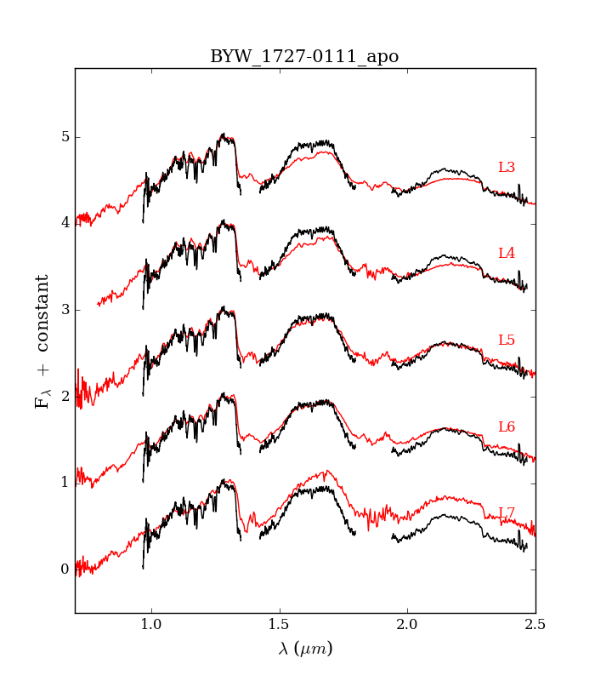

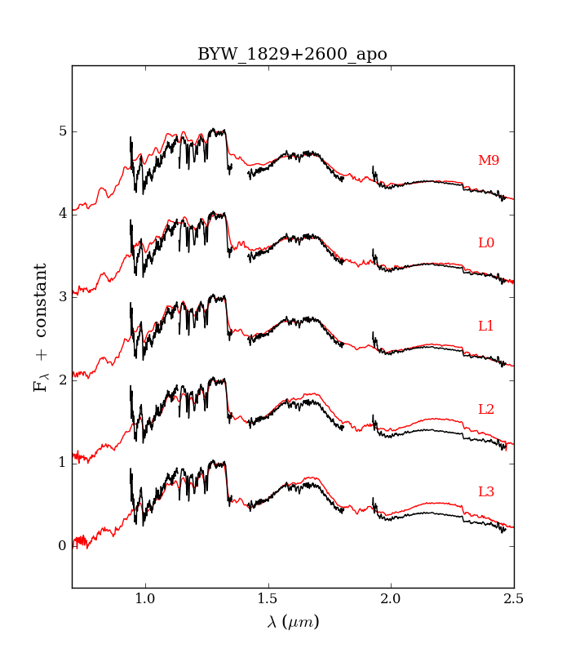

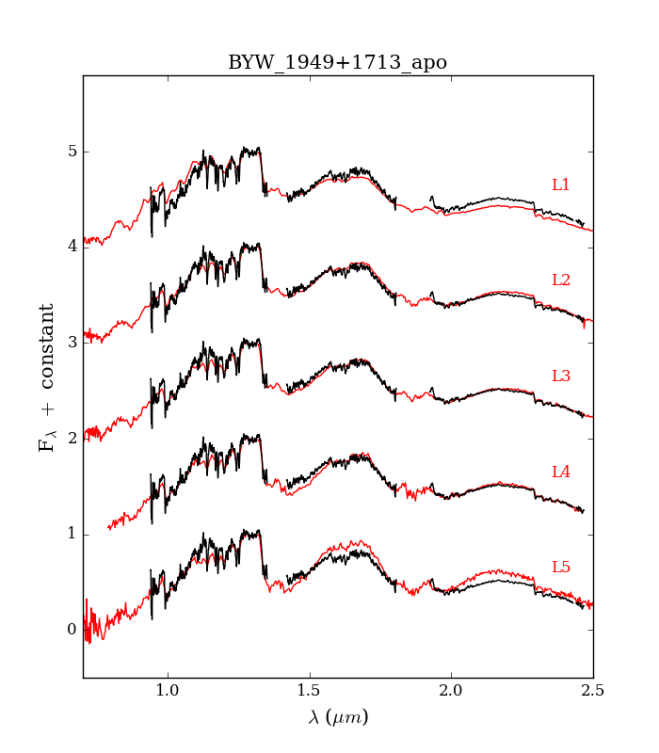

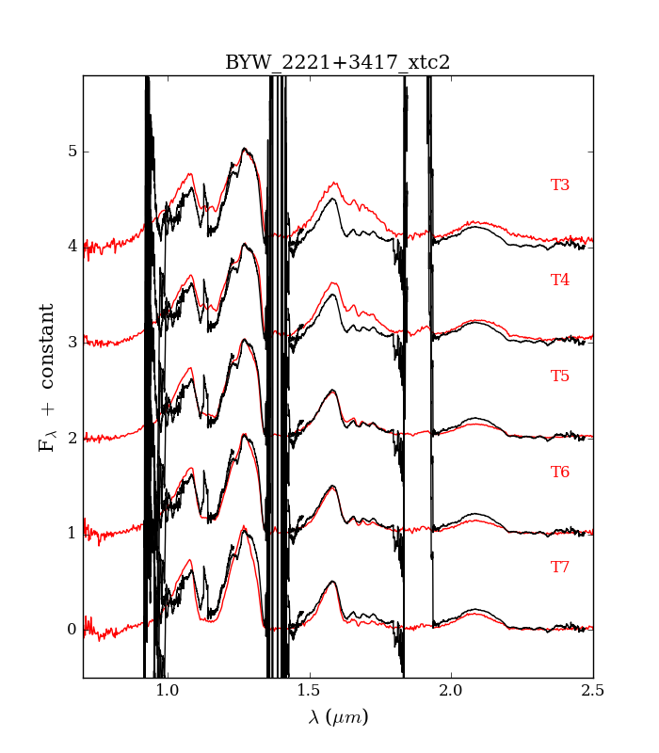



**IRTF SpeX 6/15/18**

**Observer: Jonathan Gagné**

**BYW1107+3517**

(Estimated L4.5 from W2U)

It turned out to be too faint for the weather - we had a .8" seeing, but with thin cirrus clouds that caused our sensitivity to go down. You'll see that all targets that we attempted with J > 16 have terrible S/N. That one had J=16.9. However, you can see that it seems consistent with a late L dwarf despite the low SNR.

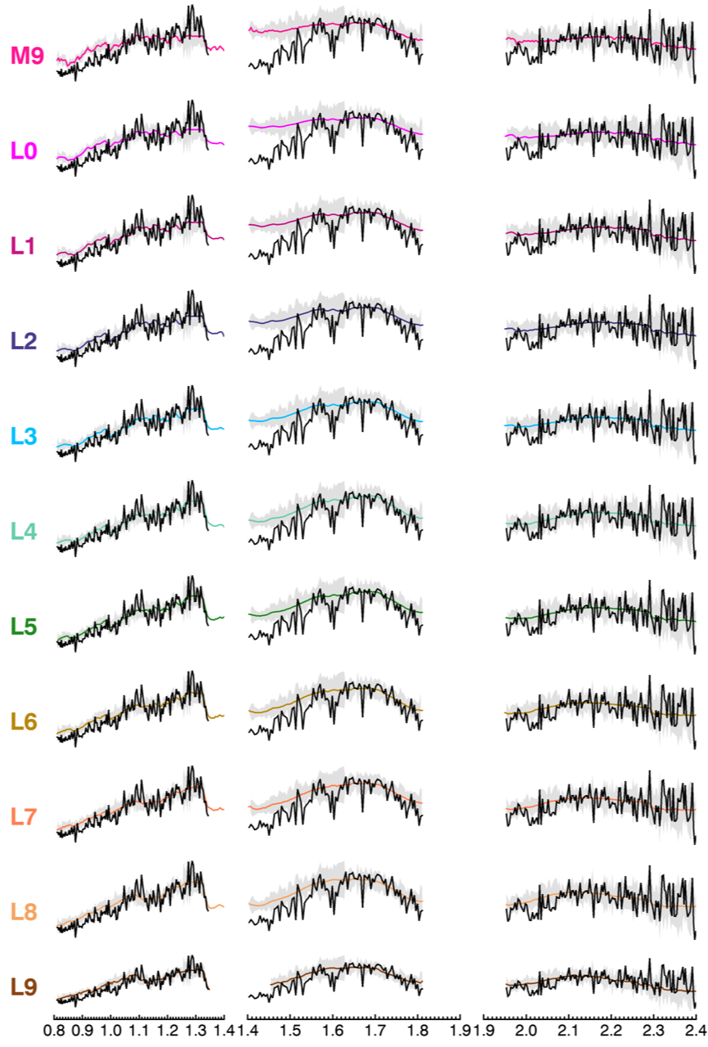

**BYW1203-0648**

(Estimated T0 from BYW)

Next I tried a brighter one (J=16.5) but that was still too faint. It does look consistent with a late L BD however.

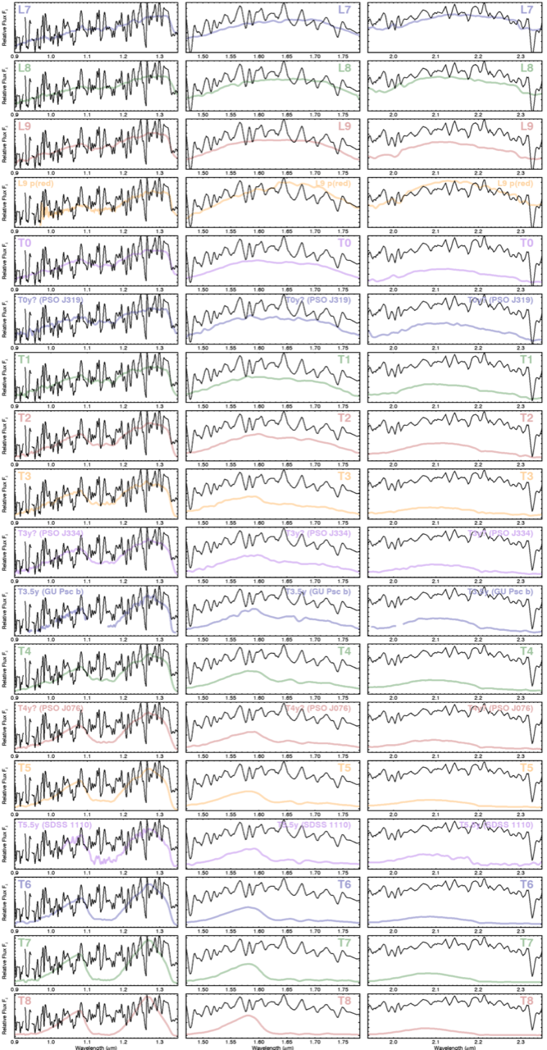

**BYW1417+0418**

(M8 comover with LSPM J1417+0418 in BYW)

So at that point I decided to do only stuff with J <= 16.2. It looks like a normal M8:

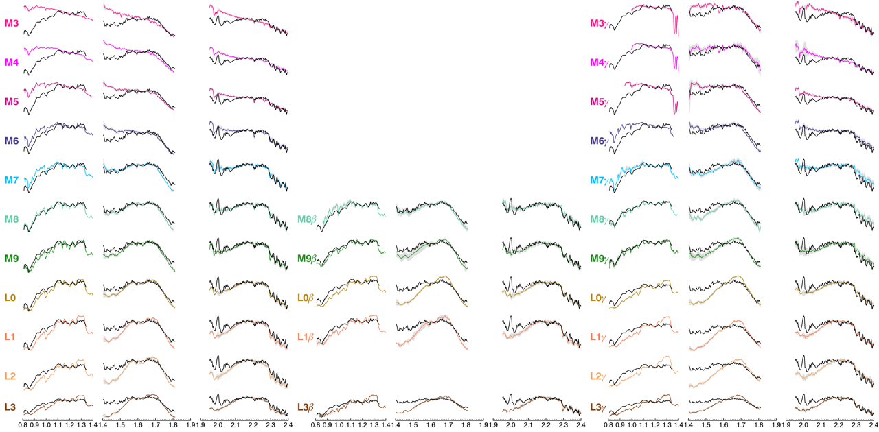

**BYW1527-1215**

(L1 comover with 2M15274030-1215503? in BYW)

This one is also quite faint (J=16.1) so the SNR is low, but it's clearly an L0 ± 1.

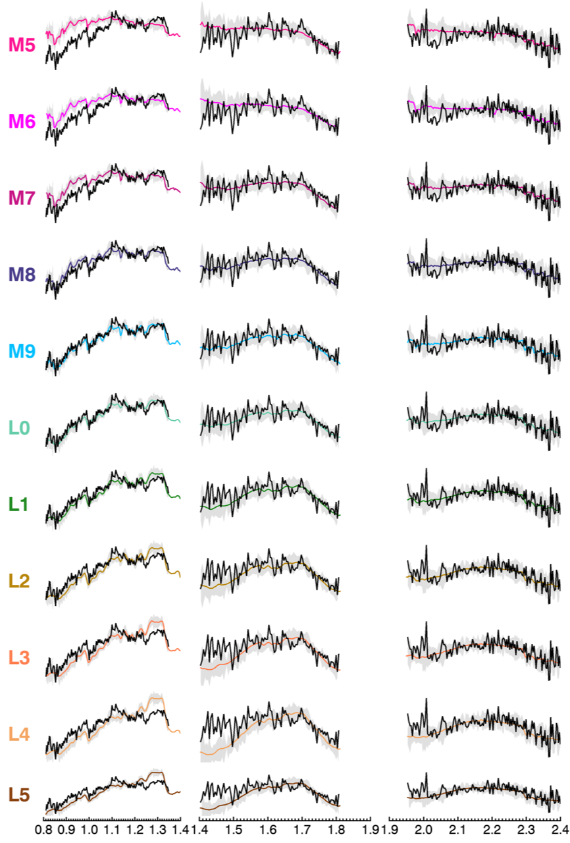

**BYW1608-1346:**

(Estimated L0 that Michaella recently added, ~75% AB Doradus candidate)

No idea what happened in the J band here, but this looks like a young M6 γ. That may explain why the colors were funky - it was probably blue in W1-W2 (early spt), but red in 2MASS (young). The Allers 2013 indices call it M7 VL-G (1n22), but the spectral type could have been affected by this bump in J band.

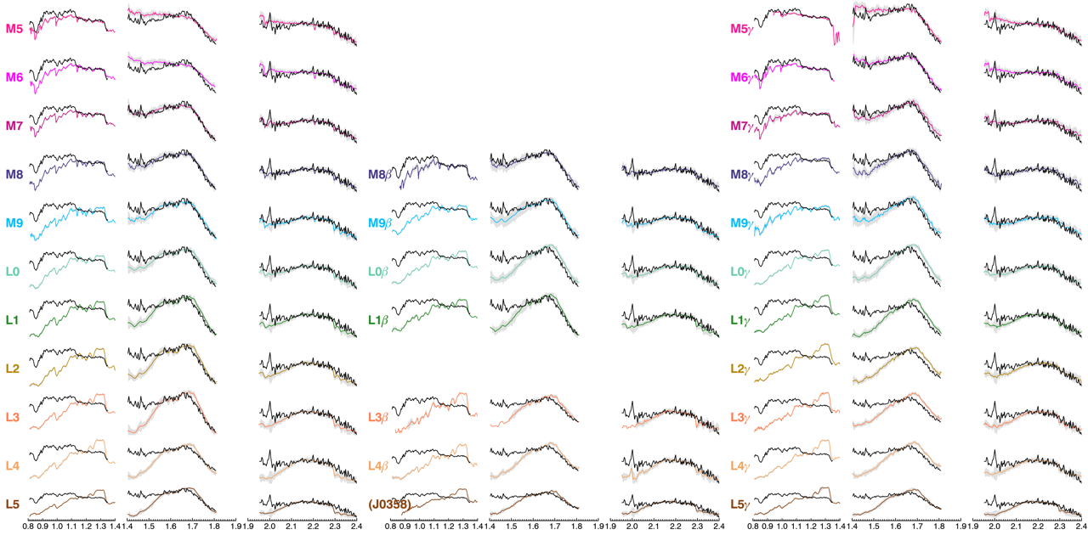

**BYW1650+5652**

(Estimated L8.5 from BYW)

This one looks like a normal T1, that's neat !

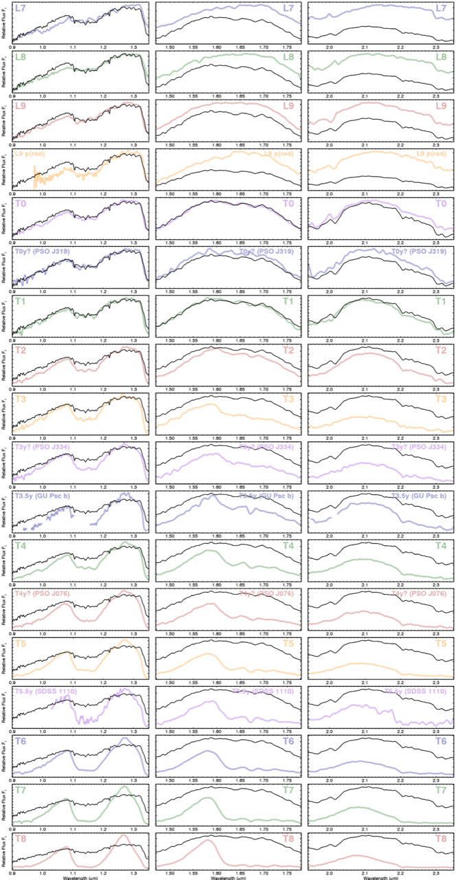

**BYW1807-0048**:

(Estimated L9.5 from W2U)

This looks like an M7 with a weird J band. I'm pretty sure this is not a mis-pointing, and it would be very surprisingly that a mispointing would have been an M7 too. I have no clue why our estimated SpT could be so wrong !

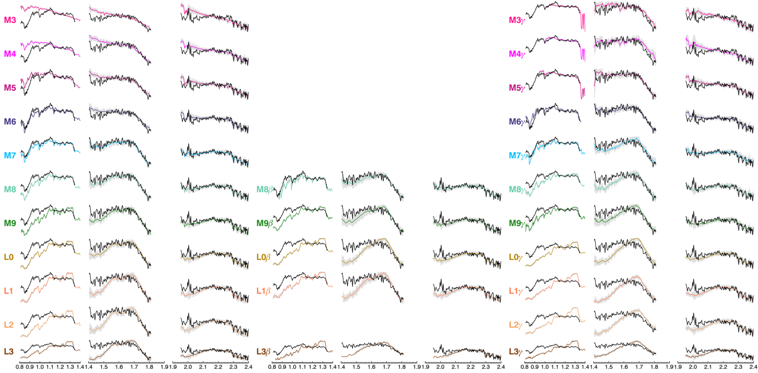

**BYW1951-1348**:

(Estimated T2 from BYW).

This one is unfortunately a clear mis-pointing. The conditions weren't great and there were several stars in the tiny guidedog FOV. I haven't marked it as observed in the Good Stuff sheet.

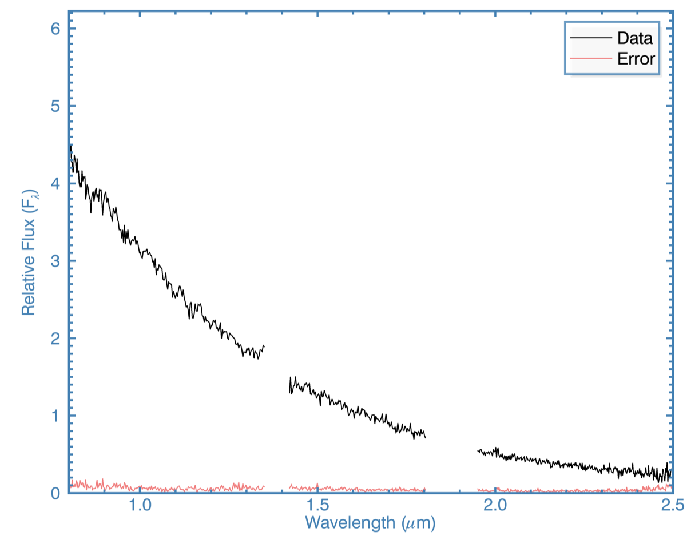

**BYW2314+6939**:

(Estimated L8 from BYW)

This one is a nice L9 !

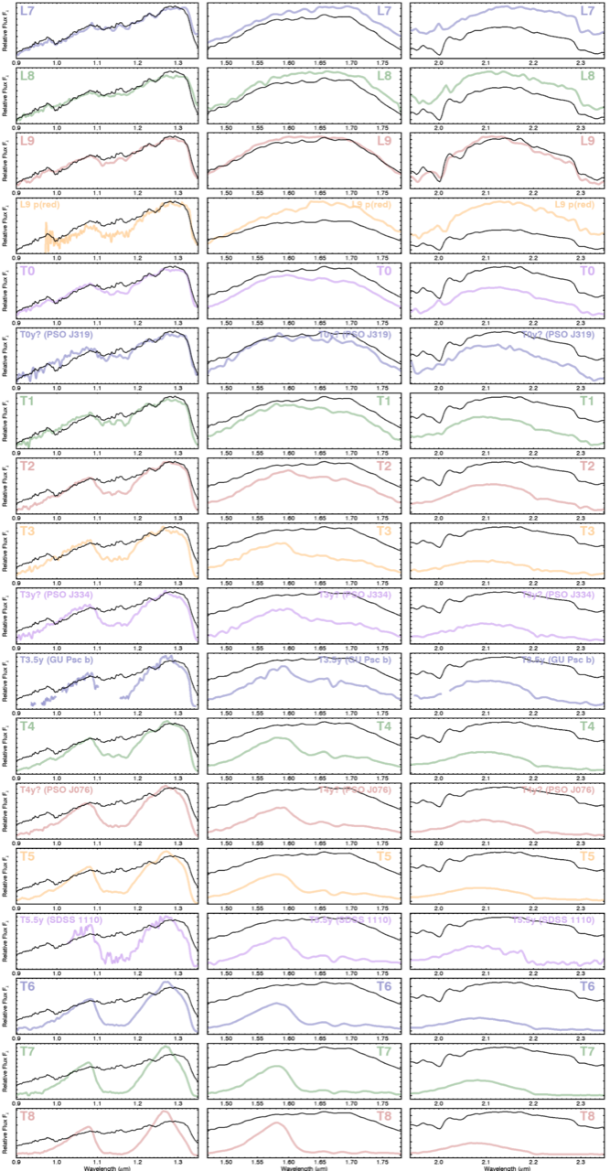

**Magellan FIRE PRISM 2/8/18**

**Observer: Jonathan Gagne**

**BYW0856-3047:**

This one looks like a regular L9. It had ~80% probability of AB Dor membership, but I doubt it's a good one. It'll be worth getting an RV just in case. Submitted by Dan

**BYW0922-8350:**

This was called a potential Y dwarf, but it looks more like a T5 to me. It was very faint so the K band was almost saturated to get an extractable signal elsewhere (we have 60% humidity tonight). So I wouldn't read too much into the K-band having almost no flux. Another possibility is that it's a subdwarf T5 and that it's underluminous compared to a normal T5, causing us to estimate its spt at ~T9. But if we want to determine whether it's really a subdwarf we'll need a better (or higher-res) spectrum. Submitted by Sam Goodman

**BYW1150-3109:**

This one looks like a normal T6. Submitted by Guillaume

**BYW1137-5320:**

This one looks like a normal T7. Submitted by Sam Goodman

**BYW1315-4936:.**

This one is a T3 dwarf, and it's slightly red !

submitted by Guillaume

**BYW1333-1607:**

This one looks like a T9, based on Adam's templates. (see below)

Submitted by Sam Goodman

**BYW1425-0617:**

The Sun started rising on the second exposure while I was observing this one, so the S/N is pretty poor and I had to use the telluric of the previous target (with a .07 airmass difference, that's not too bad at all). The J band is pretty bad though, as it's the one that gets broken first by the sunlight ! It looks like a blue T4, but I'd confirm that peculiar color with a better spectrum.

Submitted by Guillaume

**BYW1232-8500:**

This one is not a brown dwarf. I made absolutely sure that I didn’t look at the wrong target and even extracted one exposure of the 2 only other sources bright enough to be consistent with this object in the acquisition field. I put its spectral type to "STAR" in the Good Stuff sheet, and I added this explanation in the comments. By the way, that's the first false-positive from BYWP9 that I've observed, out of a dozen targets. That's a hell of a good hit rate ! I'm not attaching a spectrum because I only took one exposure per target in the field, w/o the corresponding tellurics. It is very obvious from the raw extractions (and by dividing with a previous telluric) that they can't be brown dwarfs. Submitted by Herakles

Below is 1333-1607, compared to template spectra.

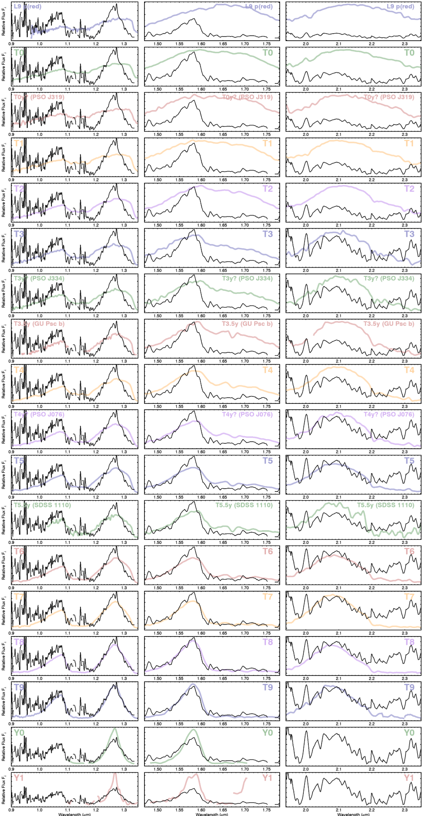

**Magellan FIRE PRISM 2/3/18**

**Observer: Jonathan Gagne**

**0749-6827**

Yesterday night I obtained a FIRE-Echelle spectrum for a T8 dwarf in BYWP9 (attached) that had possible AB Dor or Betapic kinematics given the PM that Dan had measured. The S/N is not super high, this was pretty much at the limit of what was doable with the high humidity.

I used it to measure its radial velocity at -9.6 ± 3.9 km/s. This kills any possible moving group membership. I've added this as a comment in the Good Stuff sheet,

**APO Triplespec**

**Observer: Katelyn Allers**

**W0045+7958** (the L9/T0) was submitted first by Herakles. BANYAN Sigma puts it 95% in the AB Doradus YMG. We had estimated L6.5, 46.1 pc.

**W0117+7647** (the L something) was submitted by Sam Deen, and BANYAN Sigma puts it at 81% in the AB Doradus YMG. We estimated type L8 51.4 pc. Note that the plot below is labelled +7627; it’s a typo.

With a quick by-eye check, I get L9/T0 for W0045+7958 and L-something? for W0117+7627. Both are a little ratty — but definitely brown dwarfs! -Adam

Maybe a little blue too ? That wouldn't be surprising. Looking at their spectra I bet those are just kinematic interlopers. I would expect them to be much redder if in AB Dor, but who knows. Yes the next logical step would be getting RVs. Because they're so far in the North, we'll need something like GNIRS. -John G.

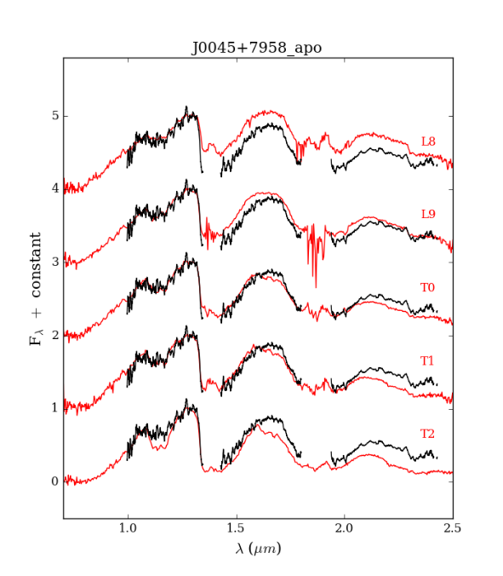

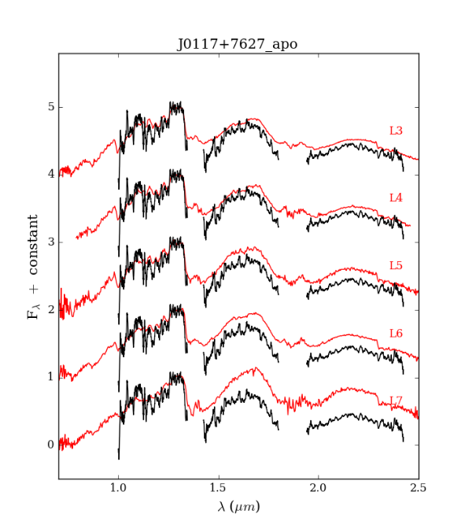

**Magellan FIRE PRISM 12/17**

**Observer: Jonathan Gagne**

Jonathan Gagne took spectra of 9 of our BD candidates with FIRE-prism on Magellan! Two turned out to be M subdwarfs. And 7 are confirmed brown dwarfs!

**J004143.14-401924.3**

Suspected T7 found by Les Hamlet. In Griffith 2012, ch1=16.128,ch2=14.914 (ch1-ch2=1.214).

I find a spectral type of T8, but the K band is much redder than my template T8.

What is the proper motion of this target ? I really want to try putting it in BANYAN !

**J011639.05-165420.5**

Target from Guillaume & Dan's latest list.

It has the W1-W2 colors of an L6, and its proper motion matches Carina-Near.

However, the spectrum looks more like a late-M subdwarf ! So that can't be a moving group member.

**J030119.39-231921.1**

Target from Guillaume & Dan's latest list.

It has the W1-W2 colors of a T1.5, and its proper motion matches Columba.

It looks like a T0 with a normal slope, but the methane is somehow much stronger in K band.

Maybe there's also a peak in H band.

**J035856.88+145706.9**

Target from Guillaume & Dan's latest list.

It has the W1-W2 colors of an L7, and its proper motion matches AB Doradus.

However, this one also looks like a mid- to late-M subdwarf ! Those are definitely not the worst kinds of contaminants !

**J064749.82-160022.3**

Target from Guillaume & Dan's latest list.

It has the W1-W2 colors of an T7.5, and its proper motion matches AB Doradus.

It looks like a perfectly normal T6 ! Since it doesn't look youthful,

it is likely just an interloper to AB Doradus.

**J060251.41-403533.7**

Suspected T5 found by Guillaume Colin.

It is a super normal T5 !

**J062050.81-300620.0**

Suspected T2.8 found by Guillaume Colin.

This one is really exciting - its spectrum looks exactly like that of GU Psc b, a planetary-mass T dwarf in AB Doradus - and I get a > 90% probability for AB Doradus in BANYAN.

Jonathan also got an echelle spectrum of this object, and it turns out that the RV is not consistent with AB Dor**.**

**J062724.99-373031.7**

Suspected T1.8 found by Guillaume Colin.

This one is much later-type than expected ! I find ~T6.5

**J074956.42-682724.2**

Suspected T5.5 found by Sam Goodman

This is one is a T8, with quite an inflated K band ! This is also a good one to try in BANYAN.

**IRTF Spex 3/19/17**

**Observer: Jackie Faherty**

**1101+5400** T5.5

See <https://arxiv.org/abs/1705.02919>