TRACER-MIP WRF-Chem output data description
This dataset contains WRF-Chem model output processed for the TRACER-MIP intercomparison. The variables were extracted from the original WRF-Chem wrfout files following the TRACER-MIP requested variable list as closely as possible. This dataset contains WRF-Chem model output processed for the TRACER-MIP intercomparison. The variables were extracted from the original WRF-Chem wrfout files following the TRACER-MIP requested variable list as closely as possible. The current export includes nearly all requested TRACER-MIP variables that are available from the WRF-Chem output, including atmospheric state variables, water and hydrometeor mixing ratios and number concentrations, precipitation, surface fields, radiation fluxes, aerosol mass/number-related fields, and most microphysical process-rate diagnostics. Two categories are incomplete or not directly included in the current export: explicit latent heating/cooling tendency variables, and aerosol effective or median radius variables. Some latent-heating-related information can still be inferred from the exported microphysical process-rate variables, but the direct heating/cooling diagnostic itself is not currently included.
The model simulations were conducted at three horizontal grid spacings: 3 km, 1 km, and 500 m (Figure1). The 1 km simulations are the primary dataset, as listed in Table 1, include ndust-nPBAP, dust-nPBAP, ndust-PBAP, ndust-PBAP-rup, dust-PBAP, dust-PBAP-rup. Each experiment was performed with three ensemble members generated by applying small, horizontally smoothed random perturbations to the initial boundary-layer potential temperature field below the simulated PBLH. The perturbations had a target variance of approximately 0.05 K$^2$, corresponding to a standard deviation of about 0.22 K.
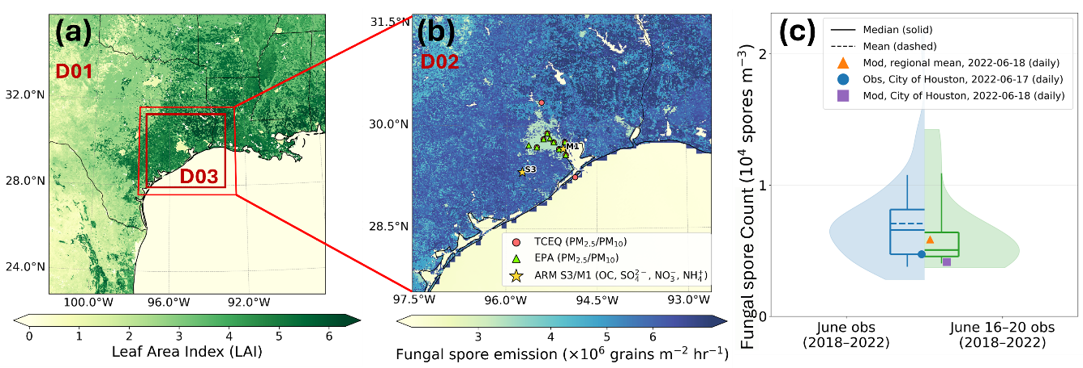
Figure.1 (a) Spatial distribution of leaf area index (LAI) from the outer domain, with the red box denoting the 1 km inner nested domain. (b) Mean fungal spore emission flux over the 1 km domain on 17 June 2022, overlaid with the monitoring sites used in this study. Yellow stars denote the ARM S3 and M1 sites, red circles mark TCEQ monitoring stations, and green triangles indicate EPA sites. (c) Comparison of simulated PBAP number concentrations with observations from the Houston Health Department. Shaded distributions represent multi-year mean observation for 2018–2022, with blue indicating the full June multi-year mean and green indicating the June 16–20 multi-year mean. Boxplots show the observed median (solid line) and mean (dashed line). Blue markers denote observed daily means reported for the City of Houston on 16 June 2022. Purple markers denote the simulated mean PBAP concentration averaged over the case period (12:00 June 17 to 06:00 June 18, 2022, UTC) sampled from the grid cell corresponding to the City of Houston, and orange markers represent the 1 km domain-mean simulated PBAP concentrations averaged over the same period.
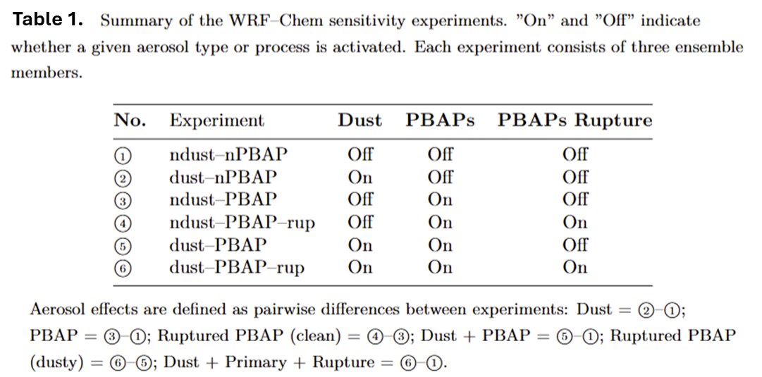
The 3 km and 500 m outputs are provided only for the ndust-nPBAP baseline case. The model output frequency is hourly. The nested simulations were performed using one-way nesting and/or ndown. Chemical initial and boundary conditions for the 3 km domain were derived from CAM-Chem. Meteorological initial and boundary conditions were driven by NAM analysis data.
Anthropogenic emissions were based on the NEI2017 emission inventory, and biogenic emissions were calculated using MEGAN. In this study, simulated PBAPs refer to fungal-spore-related biological particles and their ruptured fragments represented in the model. The fungal spore emission flux was calculated offline following Janssen et al. (2021), using meteorological inputs from the FDDA-constrained WRF simulation, including 2~m specific humidity and friction velocity, and LAI from the WRF land-surface fields (Figure 1b).

For 1hr output data, we have:

Core state and precipitation variables
Variable | Meaning | Typical dimensions | Units
pressure | Total air pressure from P + PB | Time, bottom_top, south_north, west_east | hPa
height | Geopotential height on mass levels | Time, bottom_top, south_north, west_east | m
air_density | Air density computed from pressure and virtual temperature | Time, bottom_top, south_north, west_east | kg m-3
U | Zonal wind, destaggered to mass grid | Time, bottom_top, south_north, west_east | m s-1
V | Meridional wind, destaggered to mass grid | Time, bottom_top, south_north, west_east | m s-1
W | Vertical wind, destaggered to mass grid | Time, bottom_top, south_north, west_east | m s-1
precip_accum | Accumulated precipitation from RAINC + RAINNC | Time, south_north, west_east | mm
precip_rate | Precipitation rate from change in accumulated precipitation | Time, south_north, west_east | mm s-1

Static map fields
Variable | Meaning
HGT | Terrain height
XLAT | Latitude on unstaggered or native grid
XLONG | Longitude on unstaggered or native grid
XLAT_M | Latitude on mass grid
XLONG_M | Longitude on mass grid

Radiation fluxes
Variable | Meaning
SWDNB | Downwelling shortwave flux at surface
SWUPB | Upwelling shortwave flux at surface
LWDNB | Downwelling longwave flux at surface
LWUPB | Upwelling longwave flux at surface
SWDNT | Downwelling shortwave flux at top of atmosphere
SWUPT | Upwelling shortwave flux at top of atmosphere
LWDNT | Downwelling longwave flux at top of atmosphere
LWUPT | Upwelling longwave flux at top of atmosphere

Surface time-varying fields
Variable | Meaning
HFX | Sensible heat flux
LH | Latent heat flux
ALBEDO | Surface albedo
SLP | Sea level pressure

Water and hydrometeor mixing ratios
Variable | Meaning
QVAPOR | Water vapor mixing ratio
QCLOUD | Cloud water mixing ratio
QRAIN | Rain water mixing ratio
QICE | Cloud ice mixing ratio
QSNOW | Snow mixing ratio
QGRAUP | Graupel mixing ratio

Hydrometeor number concentrations
Variable | Meaning
QNCLOUD | Cloud droplet number concentration
QNRAIN | Rain number concentration
QNICE | Ice number concentration
QNSNOW | Snow number concentration
QNGRAUPEL | Graupel number concentration

Aerosol mode and bulk fields
Variable | Meaning
nu0 | Aerosol mode number field
ac0 | Aerosol mode number field
corn | Aerosol mode number field
antha | Aerosol bulk mass field as named in the current model output
seas | Sea salt aerosol bulk mass field
soila | Soil aerosol bulk mass field
polp | Primary pollen aerosol bulk mass field
pols | Secondary pollen aerosol bulk mass field

Aerosol species family fields
Prefix or suffix | Meaning
so4 | Species prefix searched by exporter
nh4 | Species prefix searched by exporter
no3 | Species prefix searched by exporter
na | Species prefix searched by exporter
cl | Species prefix searched by exporter
org | Species prefix searched by exporter
ec | Species prefix searched by exporter
p25 | Species prefix searched by exporter
i | Suffix included when the corresponding raw variable exists
j | Suffix included when the corresponding raw variable exists
cwi | Suffix included when the corresponding raw variable exists
cwj | Suffix included when the corresponding raw variable exists

PM fields
Variable | Meaning
PM2_5_DRY | Dry PM2.5
PM10 | PM10

Additional aerosol number fields
Variable | Meaning
NPOLICE | Aerosol number-related field from raw WRF-Chem output
NDUSTICE | Aerosol number-related field from raw WRF-Chem output
NECICEI | Aerosol number-related field from raw WRF-Chem output
NECICEJ | Aerosol number-related field from raw WRF-Chem output
NIAER | Aerosol number-related field from raw WRF-Chem output

Exported microphysics process variables
Variable | Short description from the export metadata
PRC | Cloud water autoconversion
PRA | Rain-cloud water collection
NPRC | Cloud water autoconversion, number
NPRA | Rain-cloud water collection, number
NRAGG | Rain self-collection or breakup
MNUCCC | Ice from contact and immersion freezing, mass
MNUCCD | Ice from deposition freezing, mass
ICE_NUCH | Homogeneous ice nucleation from aqueous aerosol
NNUCCC | Ice from contact and immersion freezing, number
PSACWI | Ice-cloud water collection, mass
PRACI | Ice-rain collection, mass
NPSACWI | Ice-cloud water collection, number
NIACRS | Ice-rain collection, number
PSACWS | Snow-cloud water collection, mass
PRAI | Snow-cloud ice collection, mass
PRACS | Snow-rain collection, mass
PRACIS | Ice-rain collection to snow, mass
NPSACWS | Snow-cloud water collection, number
NPRAI | Snow-cloud ice collection, number
NPRACS | Snow-rain collection, number
NSAGG | Snow self-collection, number
PSACWG | Graupel-cloud water collection, mass
PRACG | Graupel-rain collection, mass
PGSACW | Snow-cloud water to graupel, mass
PGRACS | Rain to graupel, riming mass
NPSACWG | Graupel-cloud water collection, number
NPRACG | Graupel-rain collection, number
NSCNG | Snow-cloud water to graupel, number
NGRACS | Rain to graupel, number
QMULTS | Snow riming cloud water to new ice, mass
QMULTR | Snow riming rain to new ice, mass
QMULTG | Graupel riming cloud water to new ice, mass
QMULTRG | Graupel riming rain to new ice, mass
NMULTS | Snow riming cloud water to new ice, number
NMULTR | Snow riming rain to new ice, number
NMULTG | Graupel riming cloud water to new ice, number
NMULTRG | Graupel riming rain to new ice, number
PCC | Liquid condensation or evaporation tendency
PCCN | Droplet activation tendency
PRE | Rain evaporation tendency
PRD | Deposition growth of cloud ice
PRDS | Deposition growth of snow
PSMLT | Melting snow to rain
PGMLT | Graupel melting or sublimation term as stored in model output

For 5min output data (only 1km and 500m simulations), we have:
tobac_ref3d-2d_20220617.nc
Variable | Dimensions | Units | Description
time | time | seconds since 1970-01-01 00:00:00 | Time coordinate
z | z | m | Layer height; domain-mean, MSL
lat | y, x | degrees_north | Latitude
lon | y, x | degrees_east | Longitude
reflectivity | time, z, y, x | dBZ | Radar reflectivity at 10 cm wavelength
w_colmax | time, y, x | m s-1 | Column maximum vertical velocity
rain_rate | time, y, x | mm h-1 | Rain rate from accumulated precipitation; step mean
rain_rate_1h | time, y, x | mm h-1 | One-hour rolling-mean rain rate from accumulated precipitation
rtop_height | time, y, x | m | Echo-top height, defined using reflectivity > 10 dBZ and rain_rate_1h > 0.01
rtop_tempC | time, y, x | degC | Echo-top temperature at the echo-top level
rbase_height | time, y, x | m | Echo-base height, defined using reflectivity > 10 dBZ and rain_rate_1h > 0.01

tobac_w3d_20220617.nc
Variable | Dimensions | Units | Description
time | time | seconds since 1970-01-01 00:00:00 | Time coordinate
z | z | m | Layer height
lat | y, x |  | Latitude
lon | y, x |  | Longitude
w | time, z, y, x | m s-1 | Vertical velocity on mass levels

